NOTICE REGARDING INVESTIGATIVE CONSUMER REPORTS PER CALIFORNIA LAW

[Company Name], the "Company," intends to obtain information about you for employment screening purposes from an investigative consumer reporting agency (“ICRA”). Therefore, you can expect to be the subject of "investigative consumer reports" obtained for employment purposes. The term “employment purposes” means a report used for the purpose of evaluating a consumer for employment, promotion, reassignment, or retention as an employee. Investigative consumer reports may include information about your character, general reputation, personal characteristics, and mode of living. The results of this report may be used as a factor in making employment decisions. The source of any investigative consumer report will be AccuSourceHR, Inc. AccuSourceHR’s address is 11811 N. Tatum Blvd., Suite 3090, Phoenix, AZ 85028. AccuSourceHR’s telephone number is 951-734-8882 or toll-free 888-649-6272. AccuSourceHR’s email is customersuccess@accusourcehr.com and its website is www.accusourcehr.com. The Company agrees to provide you with a copy of an investigative consumer report when required to do so under California law.
Under California Civil Code Section 1786.22, you are entitled to find out what is in the ICRA's file on you with proper identification, as follows:
- In person, by visual inspection of your file during normal business hours and on reasonable notice. You also may request a copy of the information in person. The ICRA may not charge you more than the actual copying costs for providing you with a copy of your file.
- A summary of all information contained in the ICRA's file on you that is required to be provided by the California Civil Code Section 1786.10 will be provided to you via telephone, if you have made a written request, with proper identification, for telephone disclosure, and the toll charge, if any, for the telephone call is prepaid by or charged directly to you.
- By certified mail, if you make a written request, with proper identification, for copies to be sent to a specified addressee. ICRAs complying with requests for certified mailings will not be liable for disclosures to third parties caused by mishandling of mail after such mailings leave the ICRAs.
"Proper Identification" includes documents such as a valid driver's license, social security account number, military identification card, and credit cards. Only if you cannot identify yourself with such information may the ICRA require additional information concerning your employment and personal or family history in order to verify your identity.
The ICRA will provide trained personnel to explain any information furnished to you and will provide a written explanation of any coded information contained in files maintained on you. This written explanation will be provided whenever a file is provided to you for visual inspection.
You may be accompanied by one other person of your choosing, who must furnish reasonable identification. An ICRA may require you to furnish a written statement granting permission to the ICRA to discuss your file in such person’s presence.
- Please check this box if you would like to receive a copy of an investigative consumer report at no charge if one is obtained by the Company whenever you have a right to receive such a copy under California law.

City of Los Angeles
CALIFORNIA
ERIC GARCETTI MAYOR

NOTICE TO APPLICANTS & EMPLOYEES FAIR CHANCE INITIATIVE FOR HIRING ORDINANCE

This Employer is subject to the Fair Chance Initiative for Hiring Ordinance (FCIHO) (LAMC 189.00).

THESE ARE YOUR RIGHTS...

  - Employers cannot inquire about or seek information about an Applicant's Criminal History until after a Conditional Offer of Employment has been made to the Applicant*.

This includes job solicitations and applications or during any conversations or interviews

  - If an Employer decides to rescind an offer of employment based on information discovered during the criminal background check, the Employer is required to perform an Individualized Assessment.

Individualized Assessment - a written assessment that effectively links the specific aspects of the Applicant's Criminal History with risks inherent in the duties of the Employment position sought by the Applicant.
If the offer is rescinded, the Applicant must receive: Written notification
Copy of the Individualized Assessment, and
Copies of any documentation used in the Employer's decision

  - The Applicant has the right to the Fair Chance Process.

The Applicant has the opportunity to provide information or documentation to an Employer regarding the accuracy of his/her Criminal History or Criminal History Report or that should be considered in the Employer's assessment, such as evidence of rehabilitation or other mitigating factors.
The Employer is required to hold the job open for at least five (5) business days from the notification date of the proposed adverse action to allow an Applicant to submit such documentation. The Employer is required to review any documentation in order to reassess their decision.
FOR ADDITIONAL INFORMATION OR ASSISTANCE, CALL:
City of Los Angeles Department of Public Works Office of Contract Compliance
1149 S. Broadway Street, Suite 300 Los Angeles, CA 90015 Phone: (844) WagesLA - Email: WagesLA@lacity.org
*Note: Not all Applicants/Employees are covered under the FCIHO. Please see ordinance (LAMC 189.00) for more details Form FCIHO, Rev. 08/18

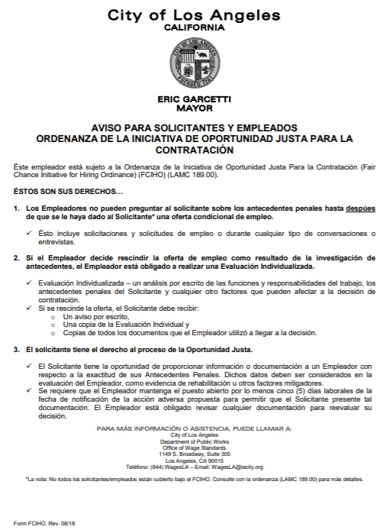

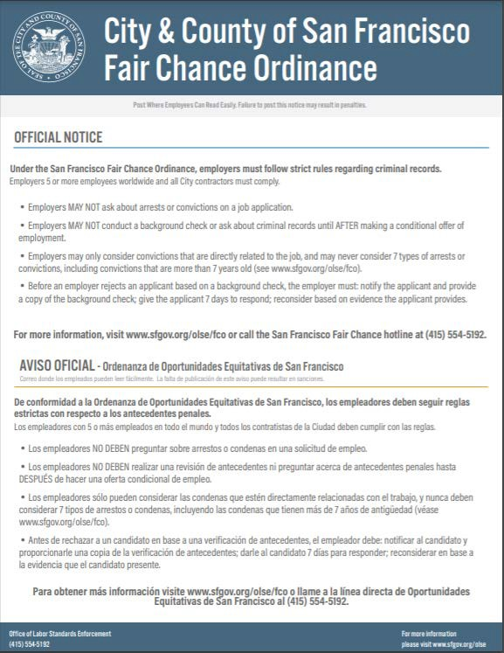

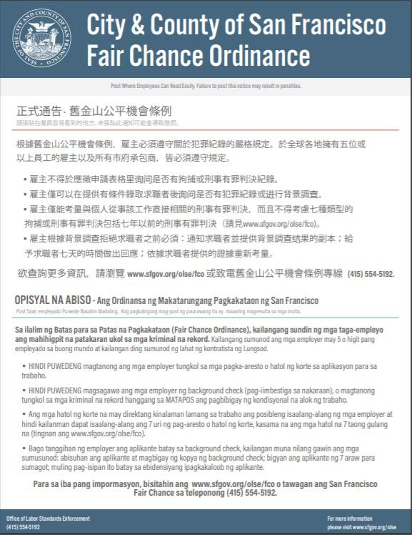

NOTICE REGARDING INVESTIGATIVE CONSUMER REPORTS PER MASSACHUSETTS LAW

With your permission and in accordance with the Annotated Laws of Massachusetts, Chapter 93 Section 53, [Company Name], the "Company," may request from a third-party consumer reporting agency an investigative consumer report in connection with your prospective or continued employment. Such reports commonly include information as to your character, general reputation, personal characteristics, or mode of living and which involve obtaining information through personal interviews. The nature and scope of any investigative consumer report requested by the Company will be as follows. If the purpose of the investigative consumer report is for employment, we may investigate the information contained in your employment application and other claims provided by you during the interview and selection process and interview people who are knowledgeable about you. If the purpose of the investigative consumer report is for non-employment purposes, including but not limited to becoming a volunteer, vendor, independent contractor, student enrollee, or student intern, we may investigate the information claimed by you during the interview and selection process, including any documentation that you have provided, and interview people who are knowledgeable about you.
The source of any investigative consumer report will be AccuSourceHR, Inc. AccuSourceHR’s address is 11811 N. Tatum Blvd., Suite 3090, Phoenix, AZ 85028. AccuSourceHR’s telephone number is 951-734-8882 or toll-free 888-649-6272. AccuSourceHR’s email is customersuccess@accusourcehr.com and its website is www.accusourcehr.com.
You have the right to receive a copy of your completed investigative report. Upon your request by contacting AccuSourceHR, Inc. as provided above, AccuSourceHR, Inc. will provide you with a copy of the completed investigative consumer report.

NOTICE REGARDING CONSUMER REPORTS PER MINNESOTA LAW

[Company Name], the "Company," may obtain a consumer report from a third-party consumer reporting agency in connection with your prospective or continued employment. This may include procurement of an investigative consumer report, which may include information obtained through personal interviews regarding your character, general reputation, personal characteristics, or mode of living. The most common form of an investigative consumer report in connection with your employment is a reference check through personal interviews with sources such as your former employers and associates, and other information sources. You have the right, upon written request, to receive a complete and accurate disclosure of the nature and scope of any consumer report.

Please check this box to receive from AccuSourceHR, Inc. a copy of any report furnished by AccuSourceHR, Inc. to the Company in accordance with your authorization. AccuSourceHR’s address is 11811 N. Tatum Blvd., Suite 3090, Phoenix, AZ 85028. AccuSourceHR’s telephone number is 951-734-8882 or toll-free 888-649-6272. AccuSource’s email is customersuccess@accusourcehr.com and its website is www.accusourcehr.com.

NOTICE REGARDING INVESTIGATIVE CONSUMER REPORTS PER NEW JERSEY LAW

With your permission, [Company Name], the "Company," may order from a third-party consumer reporting agency an investigative consumer report, which commonly includes information regarding your character, general reputation, personal characteristics, or mode of living and which involves obtaining information through personal interviews. The precise nature and scope of any investigative consumer report requested by the Company will be as follows. If the purpose of the investigative consumer report is for employment, we may investigate the information contained in your employment application and other claims provided by you during the interview and selection process, reviewing public records relating to you, and interviewing people who are knowledgeable about you. If the purpose of the investigative consumer report is for non- employment purposes, including but not limited to becoming a volunteer, vendor, independent contractor, student enrollee, or student intern, we may investigate the information claimed by you during the interview and selection process, including any documentation that you have provided, review public records relating to you, and interview people who are knowledgeable about you.

The source of any investigative consumer report will be AccuSourceHR, Inc., a third-party consumer reporting agency. AccuSourceHR’s address is 11811 N. Tatum Blvd., Suite 3090, Phoenix, AZ 85028. AccuSourceHR’s telephone number is 951-734-8882 or toll-free 888-649-6272. AccuSourceHR’s email is customersuccess@accusourcehr.com and its website is www.accusourcehr.com.

You have the right to receive a copy of your completed investigative report. Upon your request by contacting AccuSourceHR, Inc. as provided above, AccuSourceHR, Inc. will provide you with a copy of the completed investigative consumer report.

NOTICE REGARDING CONSUMER AND/OR INVESTIGATIVE CONSUMER REPORTS PER NEW YORK LAW

With your permission and in accordance with New York General Business Law Section 380, [Company Name], the "Company," may request a consumer report and/or an investigative consumer report about you from a third-party consumer reporting agency in connection with your employment or application for employment. An "investigative consumer report" is a report that includes information from personal interviews. The most common form of an investigative consumer report in connection with your employment is a reference check through personal interviews with sources such as your former employers and associates, and other information sources. The investigative consumer report may contain information concerning your character, general reputation, personal characteristics, or mode of living. You may request more information about whether or not a consumer report and/or an investigative consumer report was requested, as well as information on the nature and scope of an investigative consumer report, if any, by contacting the Company in writing.

You have the right to inspect and receive a copy of any investigative consumer report requested by the Company, upon its completion, by contacting the following consumer reporting agency:

AccuSourceHR, Inc.
11811 N. Tatum Blvd., Suite 3090, Phoenix, AZ 85028
Telephone: 951-734-8882 or toll-free 888-649-6272
Fax: 888-649-6244
www.accusourcehr.com

NEW YORK CORRECTION LAW ARTICLE 23-A

LICENSURE AND EMPLOYMENT OF PERSONS PREVIOUSLY CONVICTED OF ONE OR MORE CRIMINAL OFFENSES

Section 750. Definitions.
751. Applicability.
752. Unfair discrimination against persons previously convicted of one or more criminal offenses prohibited.
753. Factors to be considered concerning a previous criminal conviction; presumption.
754. Written statement upon denial of license or employment. 755. Enforcement.

§750. Definitions. For the purposes of this article, the following terms shall have the following meanings:
- "Public agency" means the state or any local subdivision thereof, or any state or local department, agency, board or commission.
- "Private employer" means any person, company, corporation, labor organization or association which employs ten or more persons.
- "Direct relationship" means that the nature of criminal conduct for which the person was convicted has a direct bearing on his fitness or ability to perform one or more of the duties or responsibilities necessarily related to the license, opportunity, or job in question.
- "License" means any certificate, license, permit or grant of permission required by the laws of this state, its political subdivisions or instrumentalities as a condition for the lawful practice of any occupation, employment, trade, vocation, business, or profession. Provided, however, that "license" shall not, for the purposes of this article, include any license or permit to own, possess, carry, or fire any explosive, pistol, handgun, rifle, shotgun, or other firearm.
- "Employment" means any occupation, vocation or employment, or any form of vocational or educational training. Provided, however, that "employment" shall not, for the purposes of this article, include membership in any law enforcement agency.

§751. Applicability. The provisions of this article shall apply to any application by any person for a license or employment at any public or private employer, who has previously been convicted of one or more criminal offenses in this state or in any other jurisdiction, and to any license or employment held by any person whose conviction of one or more criminal offenses in this state or in any other jurisdiction preceded such employment or granting of a license, except where a mandatory forfeiture, disability or bar to employment is imposed by law, and has not been removed by an executive pardon, certificate of relief from disabilities or certificate of good conduct. Nothing in this article shall be construed to affect any right an employer may have with respect to an intentional misrepresentation in connection with an application for employment made by a prospective employee or previously made by a current employee.

§752. Unfair discrimination against persons previously convicted of one or more criminal offenses prohibited. No application for any license or employment, and no employment or license held by an individual, to which the provisions of this article are applicable, shall be denied or acted upon adversely by reason of the individual's having been previously convicted of one or more criminal offenses, or by reason of a finding of lack of "good moral character" when such finding is based upon the fact that the individual has previously been convicted of one or more criminal offenses, unless:

- There is a direct relationship between one or more of the previous criminal offenses and the specific license or employment sought or held by the individual; or
- the issuance or continuation of the license or the granting or continuation of the employment would involve an unreasonable risk to property or to the safety or welfare of specific individuals or the general public.

§753. Factors to be considered concerning a previous criminal conviction; presumption. 1. In making a determination pursuant to section seven hundred fifty-two of this chapter, the public agency or private employer shall consider the following factors:
  - The public policy of this state, as expressed in this act, to encourage the licensure and employment of persons previously convicted of one or more criminal offenses.
  - The specific duties and responsibilities necessarily related to the license or employment sought or held by the
person.
  - The bearing, if any, the criminal offense or offenses for which the person was previously convicted will have
on his fitness or ability to perform one or more such duties or responsibilities.
  - The time which has elapsed since the occurrence of the criminal offense or offenses.
  - The age of the person at the time of occurrence of the criminal offense or offenses.
  - The seriousness of the offense or offenses.
  - Any information produced by the person, or produced on his behalf, in regard to his rehabilitation and good conduct.
  - The legitimate interest of the public agency or private employer in protecting property, and the safety and welfare of specific individuals or the general public.
2. In making a determination pursuant to section seven hundred fifty-two of this chapter, the public agency or private employer shall also give consideration to a certificate of relief from disabilities or a certificate of good conduct issued to the applicant, which certificate shall create a presumption of rehabilitation in regard to the offense or offenses specified therein.

§754. Written statement upon denial of license or employment. At the request of any person previously convicted of one or more criminal offenses who has been denied a license or employment, a public agency or private employer shall provide, within thirty days of a request, a written statement setting forth the reasons for such denial.

§755. Enforcement. 1. In relation to actions by public agencies, the provisions of this article shall be enforceable by a proceeding brought pursuant to article seventy-eight of the civil practice law and rules. 2. In relation to actions by private employers, the provisions of this article shall be enforceable by the division of human rights pursuant to the powers and procedures set forth in article fifteen of the executive law, and, concurrently, by the New York city commission on human rights.

NOTICE FOR NEW YORK CITY APPLICANTS

By signing the authorization form, you authorize [Company Name], the "Company," to provide you with a copy of your consumer report, the New York City Fair Chance Act Notice form, and any other documents, to the extent required by law, at the mailing address and/or email address you provide to the Company.

NOTICE REGARDING CONSUMER REPORTS PER OKLAHOMA LAW

In accordance with Oklahoma Statutes Title 24 Section 148, [Company Name], the "Company," will request a consumer report from a third-party consumer reporting agency to be used in connection with your potential or continued employment. You have the right, upon request, to receive a copy of any consumer report requested by the Company for this purpose.

Please check this box to receive from AccuSourceHR, Inc. a copy of any report furnished by AccuSourceHR, Inc. to the Company in accordance with your authorization. AccuSourceHR’s address is 11811 N. Tatum Blvd., Suite 3090, Phoenix, AZ 85028. AccuSourceHR’s telephone number is 951-734-8882 or toll-free 888-649-6272. AccuSourceHR’s email is customersuccess@accusourcehr.com and its website is www.accusourcehr.com.

NOTICE REGARDING CONSUMER REPORTS AND/OR INVESTIGATIVE CONSUMER REPORTS PER WASHINGTON LAW

Inconsideration of your prospective or continued employment, [Company Name], the "Company," may request a consumer report and/or an investigative consumer report from a third-party consumer reporting agency. An investigative consumer report may include information as to your character, general reputation, personal characteristics, and mode of living, and may include information from personal interviews. The most common form of an investigative consumer report in connection with your employment is a reference check through personal interviews with sources such as your former employers and associates, and other information sources.

You may request in writing a complete and accurate disclosure of the nature and scope of the investigation requested. You may also request a summary of your rights under the Washington Fair Credit Reporting Act.

The source of any consumer report and/or investigative consumer report will be AccuSourceHR, Inc. AccuSourceHR’s address is 11811 N. Tatum Blvd., Suite 3090, Phoenix, AZ 85028. AccuSourceHR’s telephone number is 951-734-8882 or toll-free 888-649-6272. AccuSourceHR’s email is customersuccess@accusourcehr.com and its website is www.accusourcehr.com.

